**Case Study Launching PayMe from HSBC**

<https://www.productmanagementtoday.com/case-study/?open-article-id=13513419&article-title=case-study--launching-payme-from-hsbc&blog-domain=mindtheproduct.com&blog-title=mind-the-product->

BY [Adam Darcy](https://www.mindtheproduct.com/profile/adam-darcy) ON APRIL 16, 2020

Before moving to super app [Gojek](https://www.gojek.com/) to lead its efforts on mass financial inclusion, Adam Darcy developed PayMe, a product that has helped to transform the way young people in Hong Kong think about [HSBC](https://payme.hsbc.com.hk/personal). Here he explains how they took PayMe from a thin MLP to become the most successful payments app in Hong Kong.

**Overview**

While I was living and working in London in 2012, I noticed a recurring problem with paying back friends after a social activity.

For example, a group of friends would go for dinner, then one person would pick up the bill. Someone in the group would inevitably (and genuinely) forget to pay them back, leaving the bill payer feeling awkward about having to remind them and the whole thing generating unnecessary bad feeling.

PayMe was designed to make requesting funds from friends easy

I tried very hard to solve the problem and had the idea of a social payments app to do it. Back then, however, the funding environment wasn’t as it is now, and this meant I only got to the proof of concept and pitching stage before moving countries for a new job.

Fast forward to 2016 when I joined HSBC in Hong Kong and repitched the idea in my first week of working there – then, the timing was great.

HSBC’s share of the millennial market had been shrinking for the previous three years. It was extremely worried about [AliPay](https://intl.alipay.com/) and [Tencent’s](http://www.tencent.com/) newly minted e-money licences as these two internet businesses broke out of mainland China.

**The Approach**

The plan was to build a low-cost [Minimum Viable Product (MVP)](https://www.mindtheproduct.com/what-does-a-successful-mvp-look-like/) to validate the idea of social payments before adding any resources. However, I quickly discovered that there’s too much brand risk for a trusted bank to take this type of lean startup approach. What’s more, social payments are designed to go viral – so instead, we went for a [Minimum Lovable Product (MLP)](https://labs.sogeti.com/the-minimum-lovable-product/) approach.

I pitched the idea by building a fully functional, iOS prototype, rather than via a PowerPoint presentation. This showed how you could send money over traditional social media, building your own social payments network.

The pitch went well and I was assigned a budget plus a single resource in a graduate named Venus (aka ‘the navigator’). Venus quickly became the key to getting everything done, including getting us a new banking licence!

We used a simple form of Jobs to be Done (JTBD) with [MoSCoW](https://en.wikipedia.org/wiki/MoSCoW_method) whereby we agreed the core job was **paying friends back.** We then identified and quantified the pain points around this core job to get our first cut and roadmap (see the process I’ve since developed [here](https://medium.com/@adamdarcy/jtbd-outcome-based-product-roadmapping-b6e3438b7f0c)).

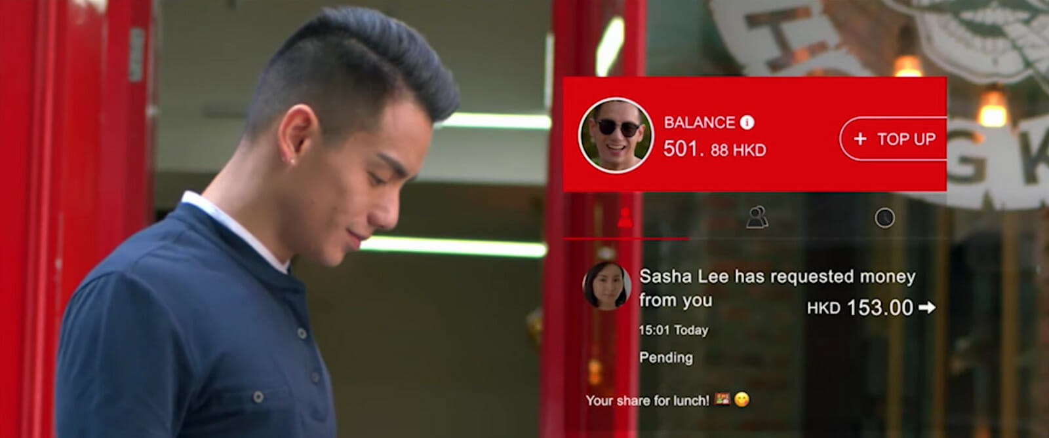The PayMe experience is fun and interactive – it even features emojis

We validated the pain points using focus groups and user interviews, and we quantified them using a survey. I remember one young student got so angry that he almost left the focus group room after we showed ‘Login with Facebook’ as the only signup option. People were extremely privacy-conscious in Hong Kong and banks were trusted.

Interestingly, I also chose a social job for MVP by allowing friends to see each other’s payments, should they choose to share them. I had a strong hunch about debt causing group instability so I wanted to move the interaction away from money and make it fun and interactive, with people sharing positive moments (I came up against a lot of resistance here, but it was a bet that would later pay off).

After a very promising product design phase, we sadly went from a very agile process to the bank’s traditional default waterfall technical delivery methodology. There were soon huge requirement documents to be written and signed off, and no contact between myself and any of the engineering team for the five-month duration of the development. Engineers were stuffed into a back office far from the main office in central Hong Kong. This lack of collaboration led to what is still the most painful and sad experience of my career – a launch-week catastrophe with the market laughing at us due to so many bugs and performance issues and calling the app ‘[PlayMe](https://www.eprice.com.hk/mobile/talk/4430/207553/1/" \t "”_blank”)’.

All the on-premise servers were overloaded due to a lack of understanding from technologists on what a transaction meant. We weren’t able to do any meaningful marketing or build any process-intensive features such as “likes” for the first 12 months – not until we had rewritten the backend and were allowed to co-locate and redesign our ways of working.

**The Results**

Miraculously after a bad first month, the thin MLP product grew exponentially, despite the catastrophic launch, showing that we’d nailed the initial scope.

We completely overachieved, smashing our targets by 300%, with 50% of users being new to HSBC and hundreds of small merchants joining too. This led to the bank giving us a massive investment to support this growing commerce ecosystem.

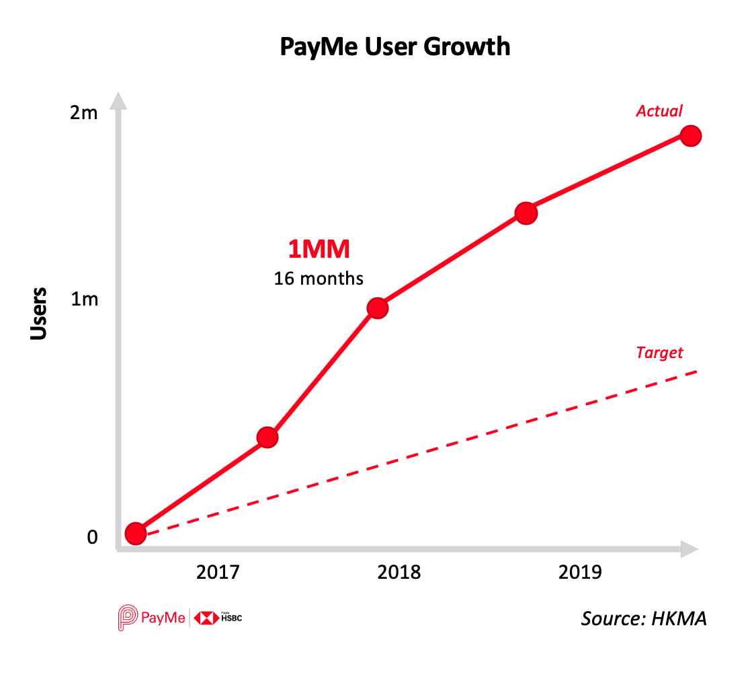

All in all, it took exactly one year from pitch to market launch. Today PayMe is the most successful payments app in Hong Kong with over 70% of Hong Kong millennials habitually using it. It has had a two-thirds share of the region’s peer-to-peer payments market since 2019, and we even invented a now commonly used verb “to PayMe”. More importantly, we were able to build a fantastic team attracting talent from companies like [Alibaba](https://www.alibaba.com/), Google, [Skyscanner](https://www.skyscanner.net/) and [PayPal](https://www.paypal.com/uk/home).

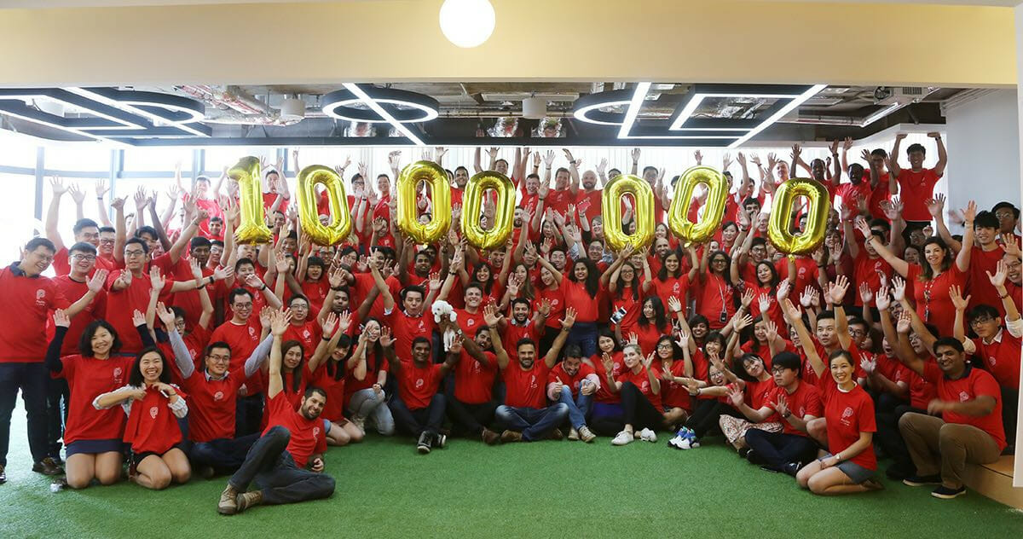PayMe surpassed 1 million users, just 17 months after launch

In addition, having supported their social relationships, the HSBC brand has undeniably improved in the minds of youngsters.

**Conclusion**

My main learning from this experience was that product managers need super-high integrity. If you have a vision for how things could be, only you can make sure the vision is realised. If you let others win because you’re tired, your product will likely fail. I had to take on almost 1,000 people all over HSBC’s global network (yes, I counted my emails!) to get what is actually a very simple product to the customer.

Whilst this was undoubtedly the most stressful experience of my career, it was completely worth it to see groups of people around a table all using the app and saying “PayMe” with a smile.

I also discovered that the 10x improvement needed to change payment behaviour doesn’t always arrive in functional value. It can be in social value – and this is how we won. This led me to develop the idea of what I believe is ”The Ultimate Social Job to be Done”. You can read more about that [here](https://medium.com/@adamdarcy/jtbd-the-ultimate-social-job-to-be-done-1d22b6607e36).



#### About

### [Adam Darcy](https://www.mindtheproduct.com/profile/adam-darcy)

With over 14 years product innovation experience, Adam currently works at South-East Asian Super App GoJek where he leads a team focused on solving financial inclusion. A self-described workaholic, he previously built and ran 2 successful startups, whilst in parallel working in tech consultancies, large fintech and a global bank all connected by his passion to create products that make a large positive impact on society. Specialises in fintech and social networks.